**TSM7-5.3g**

**Title: Update 9-12.6.3.5 TextPoint**

S-100 Maintenance - Change Proposal Form

|  |  |  |  |
| --- | --- | --- | --- |
| **Organisation** | NIWC | **Date** | 8/20/2019 |
| **Contact** | David Grant | **Email** | David.Grant1@navy.mil |

Change Proposal Type *(Select only one option)*

|  |  |  |
| --- | --- | --- |
| 1.Clarification | 2.Correction | 3.Extension |
|  | X |  |

Location (*Identify all change proposal locations)*

|  |  |  |  |
| --- | --- | --- | --- |
| S-100 Version No. | Part No. | Section No. | Proposal Summary |
| Version 4 | 9 | 12.6.3.5 | Allow TextPoint to specify location of point relative to curve |

Change Proposal

Add linePlacement to 9-12.6.3.5 TextPoint as highlighted:

|  |  |  |  |  |
| --- | --- | --- | --- | --- |
| **Role** | **Name** | **Description** | **Mult** | **Type** |
| Class | TextPoint | A graphic element for depicting text relative to a point | - | - |
| Attribute | offset | Specifies the offset from the anchor point with respect to the portrayal CRS | 0..1 | GraphicsBase::Vector |
| Attribute | rotation | Specifies the rotation angle relative to the portrayal CRS. Default = 0 | 1 | double |
| Role | linePlacement | Describes the placement of the text when the geometry is a curve | 0..1 | Symbol:: LineSymbolPlacement |
| Role | areaPlacement | Describes the placement of the text when the geometry is a surface | 0..1 | Symbol:: AreaSymbolPlacement |

Update Figure 9-18:

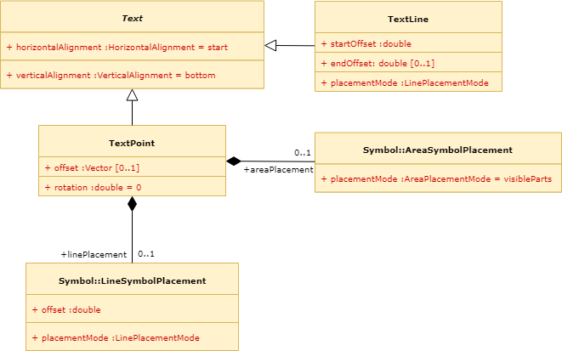

Update 9-A-2 Symbol Definition Schema:

<!-- Class TextPoint -->

<xs:complexType name="TextPoint">

<xs:complexContent>

<xs:extension base="Text">

<xs:sequence>

<xs:element name="offset" type="Vector" minOccurs="0" maxOccurs="1"/>

<xs:element name="linePlacement" type="LineSymbolPlacement" minOccurs="0" maxOccurs="1"/>

<xs:element name="areaPlacement" type="AreaSymbolPlacement" minOccurs="0" maxOccurs="1"/>

</xs:sequence>

<xs:attribute name="rotation" type="xs:double" default="0.0"/>

</xs:extension>

</xs:complexContent>

</xs:complexType>

Change Proposal Justification

Currently 9-12.6.3.5 *TextPoint* does not support specifying how far along a curve the origin should be situated, nor whether the placement should be relative or absolute.

What parts of the S-100 Infrastructure will this proposal affect?

S-100 Feature Concept Dictionary Interface or Database

S-100 Portrayal Register

S-100 Feature Catalogue Builder

S-100 Portrayal Catalogue Builder

S-100 UML Models

S-100 GitHub Schemas

**Please send completed forms and supporting documentation to the secretary S-100WG.**